**Study on emotional recognition task in individuals with addiction to short-form videos**

**Group 1**

**MC364202 Xu Qihao**

**MC364305 Liu Qianru**

**MC364483 Han Chenyu**

**Abstract**

Short-form video addiction has negative consequences on users’ mental health, such as emotion regulation. However, the question whether people with addiction to short-form video recognize differently specific emotions remains unclear. The Emotional Recognition Task is a computer-generated paradigm for assessing information processing bias between positive and negative facial expressions. In our study, we will focus on investigating the differences in recognition performance between people with addiction to short-form videos and non-addicted groups. A total of 10 Chinese university students aged from 18 to 25 will participate in our study. We compute the correlation between reaction time of the Emotional Recognition Go/No-go Task and the questionnaire score. And we also compare the difference of reaction time between the normal group and the addicted group. Finally, we get the result that the correlation between reaction time of the Emotional Recognition Go/No-go Task and the questionnaire score is not significant and the difference of reaction time between the normal group and the addicted group is also not significant. So according to our results, we have to draw the conclusion that people with addiction to short-form video do not differ from non-addicted individuals in terms of emotion recognition. We consider modifying our methodology and conduct experiments again to prove our hypotheses.

**Background**

Short-form video apps enable users to capture memorable moments and create short-form videos that last from a few seconds to a few minutes. With the popularity of short-form video applications, the public starts to be concerned about the risk of excessive use. The excessive use of short-form video apps can be considered a state in which people spend substantial time using these apps despite experiencing negative consequences.

Internet addiction can be described as “a disorder in which an individual’s inability to control his or her use of the Internet causes marked distress and/or functional impairment and that furthermore creates psychological, social, school and/or work difficulties”. Short-form video app addiction is a subcategory of Internet addiction.

Studies have affirmed that addiction may have negative consequences on users’ well-being, such as mental health problems, attention difficulties, and poor interpersonal quality. However, the effects on emotion of addiction to the short-form video app has yet to be investigated.

The emotional recognition Go/NoGo task is a good method of studying the influence of the short-form videos on emotional processing of people. The Emotional Recognition Go/ NoGo task is a modified version of the Probability Go/NoGo task (Hare et al., 2005). It is a cognitive task designed to assess information processing bias between different facial expressions. In this task, participants must respond to a particular emotional facial expression (neutral, sad, happy and so on) (Go trials) and not respond (NoGo trials) to another emotional facial expression. Reaction times (RT) will be recorded for further calculations to get emotional bias scores.

The emotional Go/No-Go task involves activation in several brain regions. Also, for each condition of the emotional recognition Go/NoGo task, their activities will be different. Brain activations are primarily in frontal, temporal, and occipital brain regions, in addition to limbic and motor areas (Brown et al,2016). The amygdala and cingulate cortex, motor cortex, cerebellum, inferior frontal gyrus, right caudate nucleus and ventral striatum (Hare et al.,2005).

All conditions activated left primary sensory and motor cortices, and inferior parietal cortex, particularly in the left hemisphere. In addition, the three no-go conditions selectively recruited premotor cortex, ACC, DLPFC, and basal ganglia. Regions activated by both nonemotional and emotional inhibition were DLPFC, premotor cortex, ACC, Broca’s area, dorsal striatum, and thalamus. Specific for the emotion task, activation was observed in left inferior PPC, and the posterior inferior frontal and anterior insular cortices. During the go conditions, responding to sad faces recruited the left subgenual cingulate cortex when compared with responding to happy faces. During the nogo conditions, inhibiting for sad faces, but not happy faces, preferentially activated a region of pregenual ACC that was more dorsal than that observed for the go condition (Shafritz et al.,2006).

PCG, ACG, anterior SMG, posterior SMG, anterior MTG, posterior MTG, SFG, FP are related to emotional face expression recognition (Arato et al.,2023).

Internet addiction has been found to be related to deficits in emotional recognition, as indicated by many studies. Individuals with problematic internet use (PIU) and excessive smartphone use (ESU) show impairments in recognizing emotional face expressions (EFE) (Arato et al.,2023). Specific internet addiction, such as addiction to games and social networks, has been found to be associated with impaired inhibitory control and social anxiety, which may affect emotion recognition (Dieter et al.,2017). Additionally, internet-addicted urban left-behind children have been found to have differences in facial expression recognition, with a processing mode characterized by earlier gaze acceleration and uniform extraction of information in pictures (Ge et al.,2017). Also, they showed a preference for negative emotions in facial expression recognition (Ge et al.,2014). Though several researches have been done on Internet addiction, there haven’t been researches on the influence of short-form videos on emotion recognition with the popularity of short-form videos these years.

**Idea**

The study aims to investigate:

1. Whether people with addiction to short-form video differ from non-addicted individuals in terms of emotion recognition.
2. How people with short-form video addiction differ from non-addicted individuals in terms of emotion recognition.

**Experimental design**

QUESTIONNAIRE

The Mobile Phone Addiction Index (MPAI) ([Huang et al., 2014](https://www.frontiersin.org/articles/10.3389/fpsyg.2022.894121/full#B18)) is a widely used instrument to measure mobile phone addiction. In view of the short video addiction as a part of Internet addiction, the short video addiction scale for college students is compiled based on MPAI.

This scale contains 17 items and 4 subscales: Inability to Control Craving, Anxiety and Feeling Lost, Withdrawal and Escape, and Productivity Loss. Each item of the MPAI was rated on a 5-point Likert scale (with 1 = not at all and 5 = always). A higher MPAI score reflects greater levels of addiction. ([Huang et al., 2014](https://www.frontiersin.org/articles/10.3389/fpsyg.2022.894121/full#B18)).

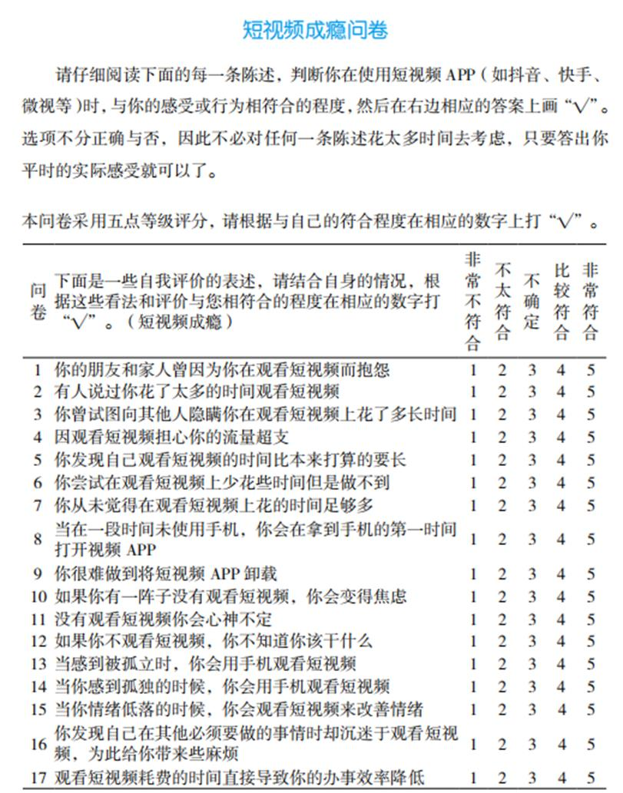

In this experimental design, we will investigate attention allocation and emotion regulation abilities in participants under different emotional conditions. We will have a total of 10 participants, consisting of 5 individuals with short video addiction and 5 non-addicted individuals.

Participants will be informed about the target emotions, which include happiness, sadness, and neutrality. They will be instructed to press a button only when the target emotion is present. The task will consist of six blocks, each presenting a series of facial expressions:

Positive target (press button when seeing happy faces) / Negative distraction (do not press button when seeing sad faces)

Positive target / Neutral distraction

Neutral target / Positive distraction

Neutral target / Negative distraction

Negative target / Positive distraction

Negative target / Neutral distraction.

We will use the updated Chinese Facial Affective Picture System with a total of 60 images for each neutral, positive, and negative facial expression. The experimental procedure will progress as follows:

Presentation of a plus sign interface for 1 second.

Presentation of facial expressions.

Participant presses the button.

Record and calculate the reaction time (RT) for all "hits" in each of the six conditions.

Emotion bias scores will be calculated by subtracting the RT in the sad target/happy interference condition from the RT in the happy target/sad interference condition.

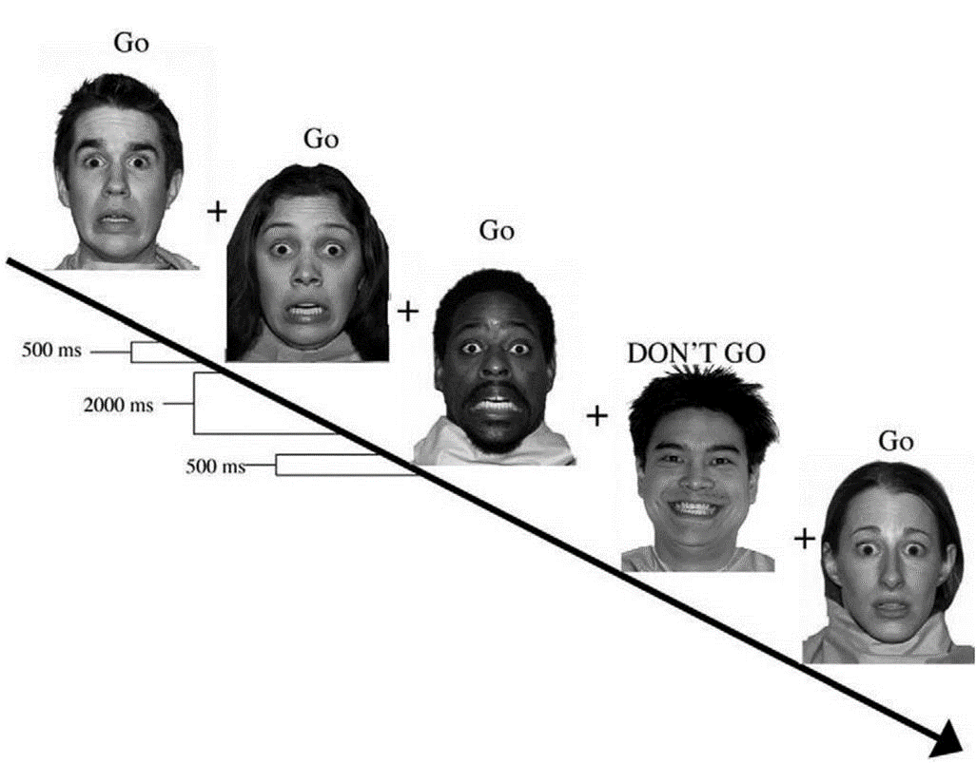

We will assess the internal consistency reliability of the questionnaire using Cronbach’s alpha. We will also calculate the weighted average reaction time for recognizing different emotional facial expressions, using accuracy rates as the weighting factor. Then Spearman rank correlation analysis will be used to see if there was any link between reaction times for different facial expressions and scores on the short video addiction questionnaire. Also, a comparative analysis will be carried out using independent samples T-test to detect any statistically significant differences between the groups (addicted and normal).

This experimental design aims to explore how participants with short video addiction differ from non-addicted individuals in terms of attention allocation and emotion regulation. By examining their behavioral responses and neural activation patterns, we hope to gain a better understanding of the impact of addiction on emotional processing and cognitive control.

**Results**

To investigate the impact of short video addiction on facial recognition ability, we conducted a comprehensive analysis using SPSS software. The study involved ten participants, grouped according to their self-reported levels of addiction: addicted, inclined, or none. The analysis aimed to uncover potential differences in facial recognition ability among these groups.

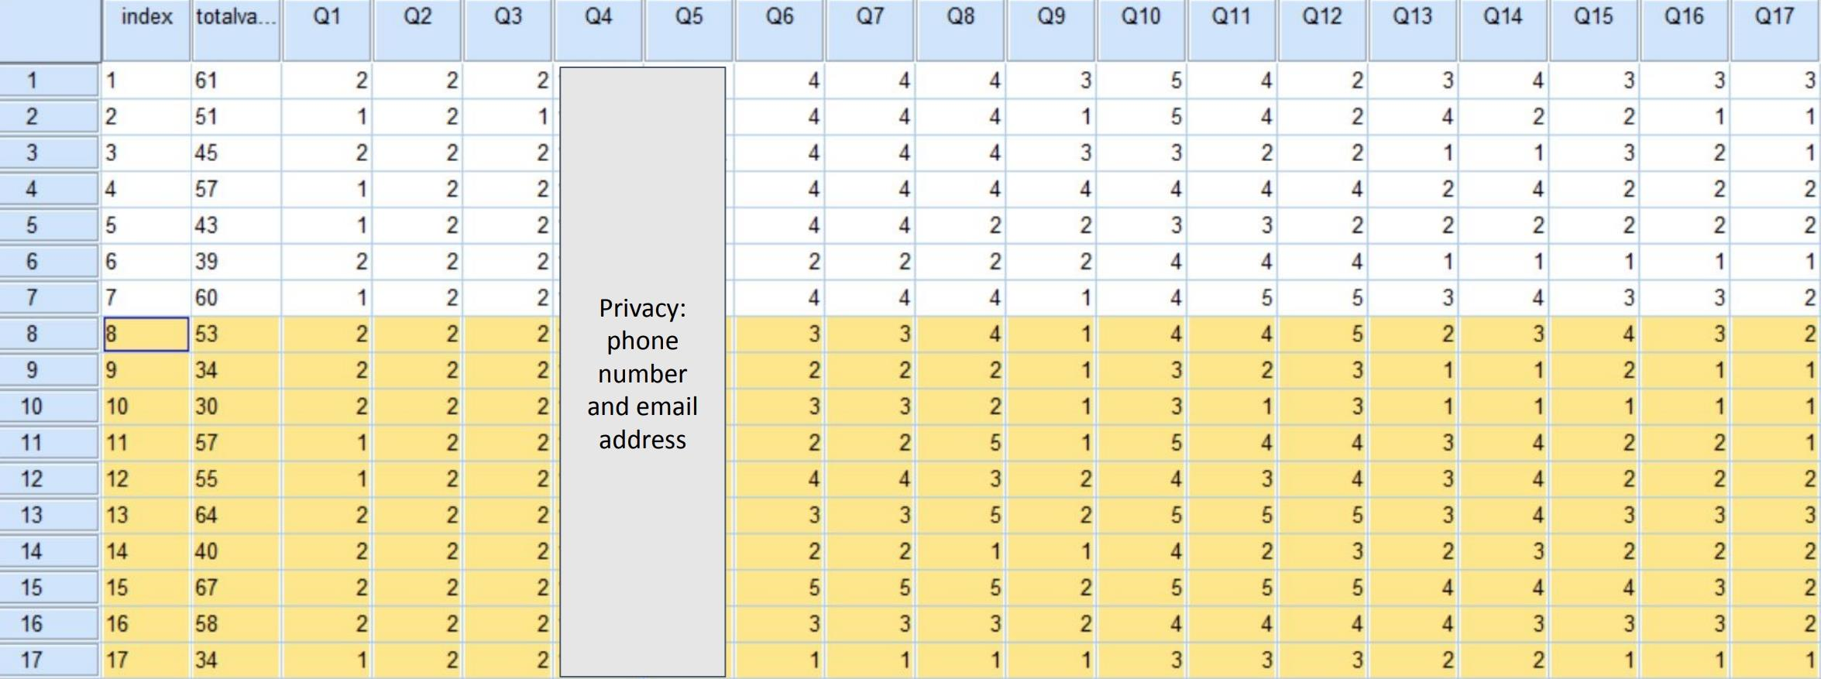

Internal Consistency Reliability:  
First, we assessed the internal consistency reliability of the questionnaire we chose using Cronbach’s alpha. With a value greater than 0.6 considered indicative of high internal consistency, the alpha score of 0.919 obtained from the original questionnaire is consistent with paper which provided questionnaires.

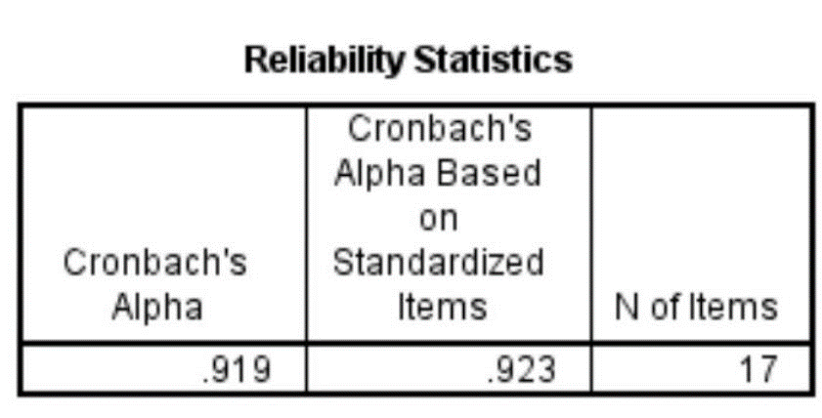

Behavioral Data Analysis:  
We then analyzed behavioral data, focusing on reaction times (RTs) and recognition accuracy. We calculated the weighted average reaction time for recognizing different emotional facial expressions, using accuracy rates as the weighting factor. This approach ensured that the analysis captured both the speed and correctness of responses across various emotional expressions. We ran a Spearman rank correlation analysis to see if there was any link between reaction times for different facial expressions and scores on the short video addiction questionnaire. For the 10 participants, we looked at how quickly they recognized happy, neutral, and sad expressions. The results showed a weak negative correlation between the reaction time for happy expressions and addiction scores (*rho*=-0.225, *p*=0.532), and a moderate negative correlation for neutral expressions (*rho*=-0.377, *p*=0.283). In contrast, the reaction time for sad expressions showed a weak positive correlation (*rho*=0.188, *p*=0.602). Each of them was not significant. This analysis did not reveal significant correlations between the degree of addiction and either RTs or accuracy scores, suggesting no strong linear relationship.

These measures offered insights into the cognitive processing speed and recognition performance of each participant group.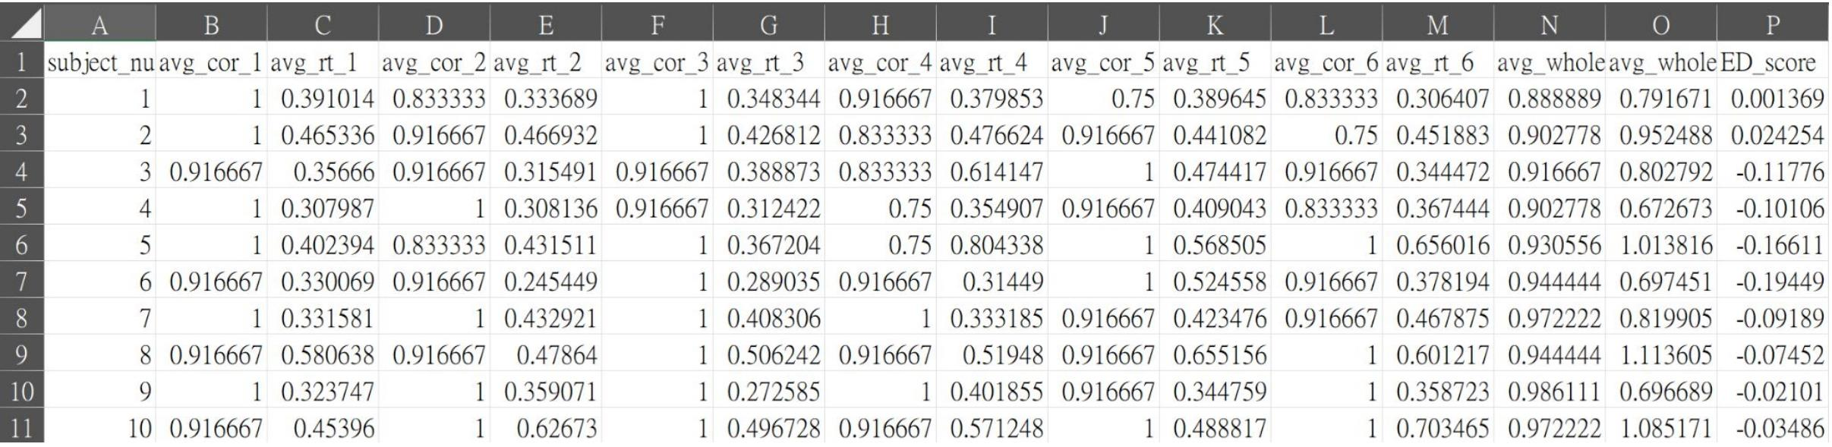

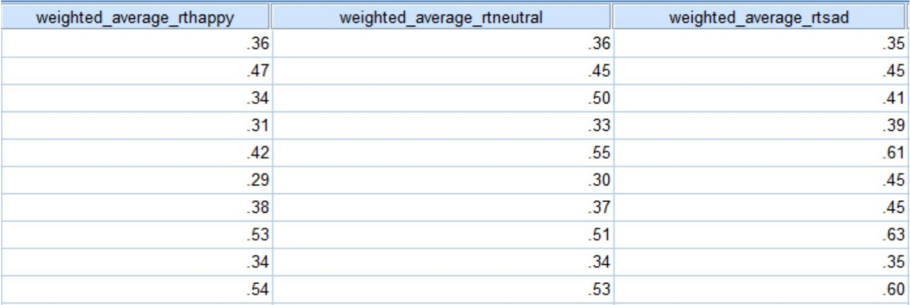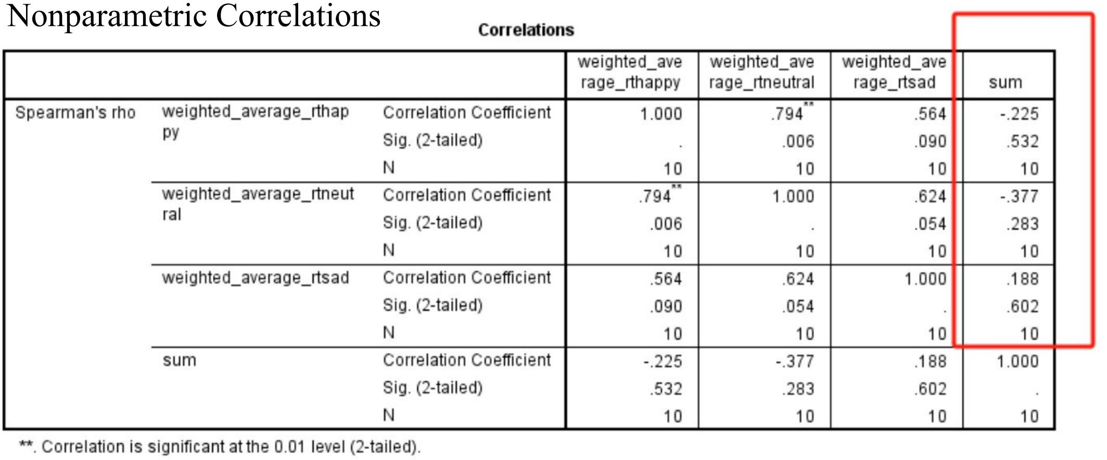

Comparative Analysis:  
A comparative analysis was carried out using independent samples T-test to detect any statistically significant differences between the groups (addicted and normal). For happy expressions, the t-test revealed no significant difference in reaction times between the two groups (t (8) = 1.118, p = .296). No significant differences emerged for neutral expressions either (t (8) = 2.250, p = .055), though the p-value suggests a potential trend that could be explored further. The analysis for sad expressions showed similar results, with no significant differences found (t (8) = 1.027, p = .334).

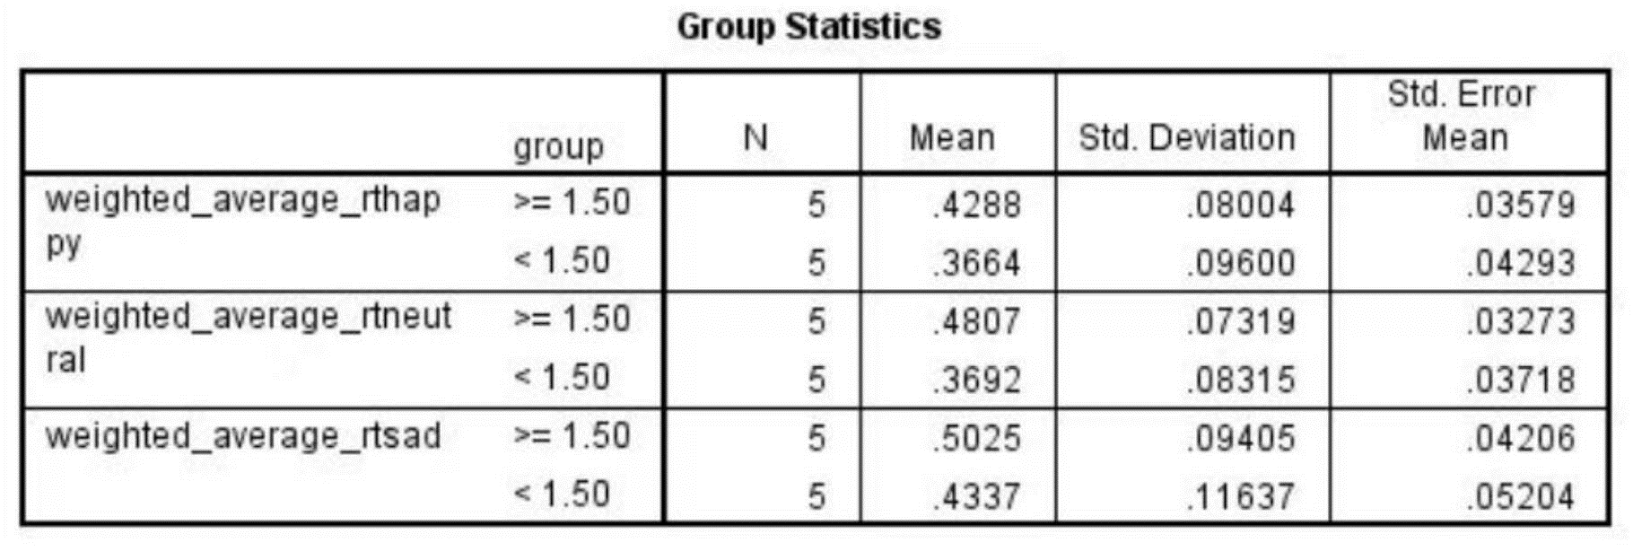

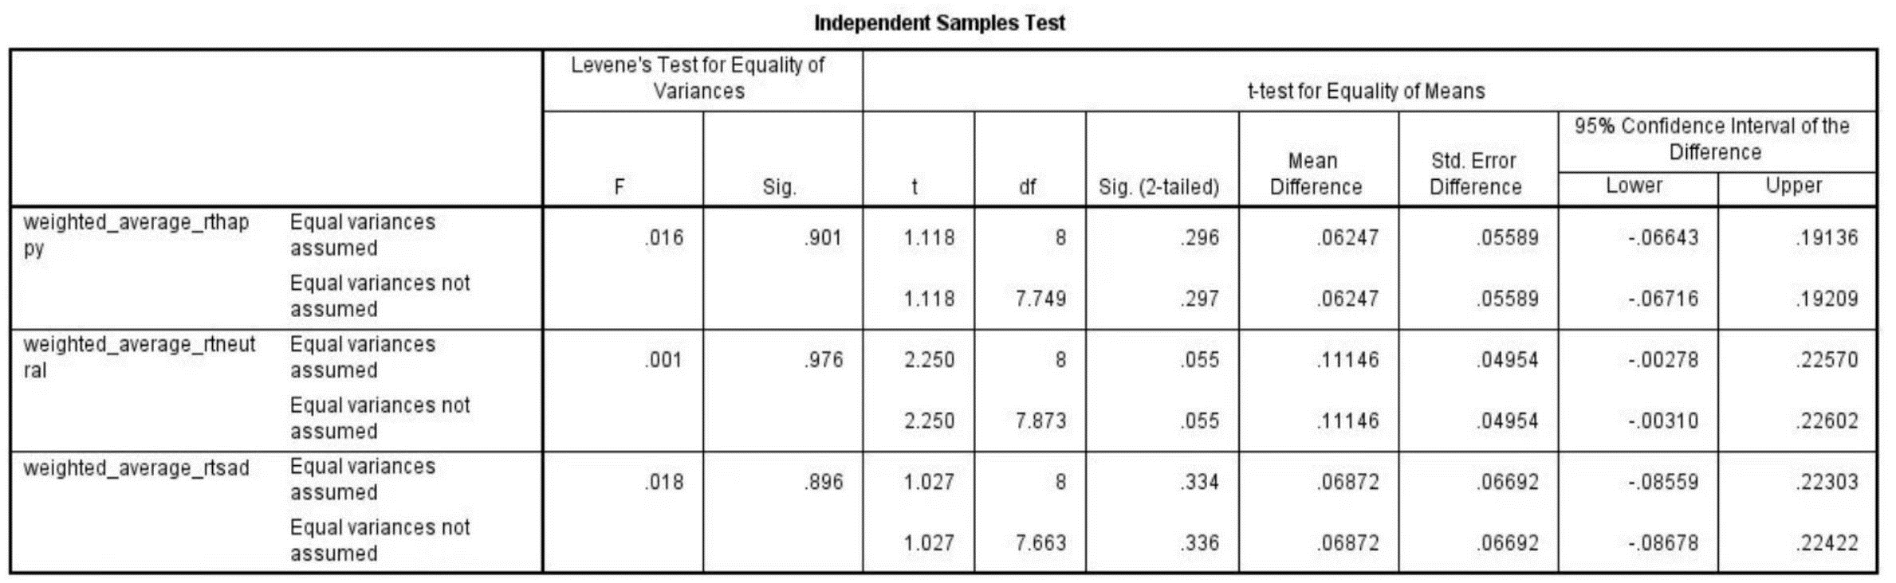

These findings indicate that, under our experimental conditions, there is no significant difference in the ability to recognize different emotional expressions between the normal and addicted groups. However, the near-significant result for neutral expressions might hint at a subtle effect worth investigating in larger studies.

**Conclusion**

Because of the insignificance of the correlation between reaction time of the Emotional Recognition Go/No-go Task and the questionnaire score and the difference of reaction time between the normal group and the addicted group. So we have to draw the conclusion that people with addiction to short-form video do not differ from non-addicted individuals in terms of emotion recognition and people with short-form video addiction do not differ from non-addicted individuals in terms of emotion recognition.

**Discussion**

After reflecting on our experimental design, we found some problems and came up with some modifications on our methods:

1. Increase sample size. The small size of our sample makes the experimental data with great noise and bias, bigger sample size can effectively resolve these problems.

2. Exclude participants with depression or anxiety. Diseases or disorders like depression and anxiety may affect the result data of the experiments which can be noise for our data, we should exclude them in our experiment.

3. Conduct more assessments before experiment, such as personality traits, IQ, gender etc. Factors like personality traits, IQ or gender may also influence people's experiment results. We should also consider them as variables in our experiment to eliminate their influence.

4. Add neuroimaging techniques to explore underlying mechanisms. Due to some reason, we cannot use fNIRS in this experiment, we will use fNIRS neuroimaging technique to get more direct data for emotional recognition processes in the future for better data analysis.

Though now we cannot prove our hypotheses, when we prove our hypotheses, our study will contribute to understanding the effect of addiction to short-form videos on emotional processing. It provides insights into the underlying mechanisms of emotional processing. It helps us understand how emotions are regulated and processed in individuals with addiction to short-form videos. Research on emotional tasks in individuals with addiction to short-form video is crucial for addressing the growing concerns surrounding excessive use of these platforms. By comprehensively examining the impact on emotional regulation, decision-making processes, and the influence of emotional content, we can develop effective interventions and preventive strategies to mitigate the negative consequences of short-form video addiction and promote healthier media habits. Overall, the research has significant implications for public mental health.

**Reference**

Akos, Arato., Szilvia, Anett, Nagy., Gábor, Perlaki., Gergely, Orsi., Anna, Szente., Gréta, Kis-Jakab., Eszter, Áfra., Husamalddin, Ali, Mohhamad, Alhour., Norbert, Kovács., József, Janszky., Gergely, Darnai. (2023). Emotional face expression recognition in problematic Internet use and excessive smartphone use: task-based fMRI study. *Dental science reports*, doi: 10.1038/s41598-022-27172-0

Brown, B. K., Murrell, J., Karne, H., & Anand, A. (2017). The effects of DAT1 genotype on fMRI activation in an emotional go/no-go task. *Brain imaging and behavior*, *11*(1), 185–193. <https://doi.org/10.1007/s11682-016-9516-7>

Hare, T. A., Tottenham, N., Davidson, M. C., Glover, G. H., & Casey, B. J. (2005). Contributions of amygdala and striatal activity in emotion regulation. *Biological psychiatry*, *57*(6), 624–632. <https://doi.org/10.1016/j.biopsych.2004.12.038>

Huang H., Niu L., Zhou C., Wu H. (2014). Reliability and validity of mobile phone addiction index for Chinese college students. Chin. J. Clin. *Psychol*. 22 835–838. 10.16128/j.cnki.1005-3611.2014.05.062

Julia, Dieter., Sabine, Hoffmann., Daniela, Mier., Iris, Reinhard., Martin, Beutel., Sabine, Vollstädt-Klein., Falk, Kiefer., Karl, Mann., Tagrid, Leménager. (2017). The role of emotional inhibitory control in specific internet addiction - an fMRI study. *Behavioural Brain Research*, doi: 10.1016/J.BBR.2017.01.046

Pınar, Ünal-Aydın., Kuzeymen, Balıkçı., İpek, Sönmez., Orkun, Aydın. (2020). Associations between emotion recognition and social networking site addiction. *Psychiatry Research-neuroimaging*, doi: 10.1016/J.PSYCHRES.2019.112673

Shafritz, K. M., Collins, S. H., & Blumberg, H. P. (2006). The interaction of emotional and cognitive neural systems in emotionally guided response inhibition. *NeuroImage*, *31*(1), 468–475. <https://doi.org/10.1016/j.neuroimage.2005.11.053>

Ying, Ge., Xiaofang, Zhong., Wenbo, Luo. (2017). Recognition of Facial Expressions by Urban Internet-Addicted Left-Behind Children in China. *Psychological Reports*, doi: 10.1177/0033294117697083

Ying, Ge., Jinfu, Zhang., Yuanyan, Hu. (2014). Study of Implicit Preferences in Facial Expression Recognition of Urban Internet-Addicted Left-Behind Children in China. *Journal of Health Education Research & Development*, doi: 10.4172/2332-0893.1000117